**2- The Boiling point(B.P)**

**Background Theory:-**

liquid organic compounds consists of particles that are less regularly arranged than in solid compounds. each particle is attracted by a number of other particles, by an intermolecular force. Boiling is the change from the liquid state to the vapor state, where the particles are freer in motion. Thus an amount of energy is needed to break off the intermolecular forces, and to bring the vapor state and the liquid state into equilibrium under the atmospheric pressure.

such an amount of energy is known as the **Boiling point.** Apure liquid will have similarly a sharp boiling–point which will remain constant until the whole of the liquid has boiled off. Impure liquid boil at different range of temperature, depends largely on the physical nature of the impurities.

**Boiling point** **(B.P)**? is the temperature at which it’s vapor pressure equals the atmospheric pressure over the liquid, or temperature at which the vapor and liquid phases are in equilibrium at a given pressure.

pressure of the vapor liquid = atmospheric pressure

**Methods of determination of the boiling point:**

1- Distillation :

This method is used when a sufficient amount of liquid organic material available

2- Siwoloboff´s method:

Generally it is assigned to the boiling degree manner as more accurate than the method of distillation

**Boiling point based on such factors as :**

1- The purity of substances: Not like M.P here in B.P: The impurities will be increase. why ? H.W

2- Molecular weight (when it increase ; the boiling point also increase ).

A-Straight chains

B.p of CH3-CH2-CH2-CH2-CH3  > B.p of CH3-CH2-CH3 . why ? H.W

B- Degree of branching:

The more highly branch lead to lower B.P

CH3-CH2-CH2-CH2-CH2-OH(138oC) > CH3-CH2-CH-CH2-OH (129oC) >

CH3

CH3

CH3-C-CH2OH (114oC) . why ? H.W

CH3

C- The Natural of function group:

The more polar lead to higher boiling point .

CH3-CH2-S-CH2-CH3 (B.P 92oC) > CH3-CH2**-O-**CH2-CH3 (B.P 35oC).

why ? H.W

3- Types of Forces

**Dipole – Dipole (di-di) , Hydrogen bond ( H.B)**

**EX (di-di) : HCl**

**EX (H.B): R-CO2H > ROH > RNH2 > Aldehydes , Ketones > Hydrocarbons**

4- Pressure : when increase it ; the Boiling point also increase .

why? H.W

This idea will be used when the liquid is decomposed in its B.P So; we used pressure

**EXPERIMENTAL PROCEDURE**:-

Apparatus for determining boiling points of small quantities of the liquids. It only consists of a dry–clean Pyrex test tube, and a thermometer.

**1-** In a capillary tube closed from one end is inverted upside down and is attached to thermometer by a rubber ring.

**2-** Place them in a clean and dry test tube containing a small quantity of a liquid whose boiling point is to be measured (the rubber ring should be above the surface of the liquid).

**3-** The whole assembly is to be placed in an oil bath.

**4-** Start heating with continuous stirring until a rapid stream of bubbles comes out of the capillary tube ( inside the liquid).

**5-** Remove the flame and allow the oil bath to cool so that the bubble stream will become slower and slower as the temperature drops until a point is reached at which bubbling ceases and the liquid starts to raise inside the capillary tube.

**6-** Record this temperature as the boiling point.

**Boiling point Instrument by Hot plat** 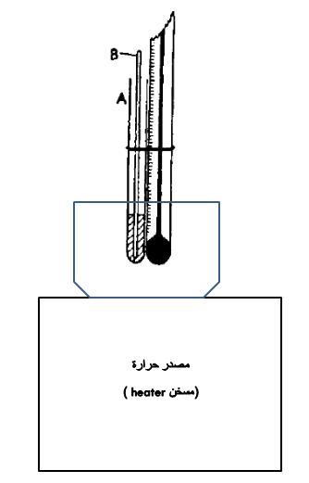

**Lecturer:** **Hussein Nasser AL-Salman**